**Capstone Project – The Battle of the Neighbourhoods**

**Introduction:**

New York City is one of the largest and ethnically diverse cities in the world. It is the largest city in the United States and for a long period of time, served as an entrance point into the US for many immigrants around the globe. NYC is home to over 8 million people and the city alone houses more people than 37 states. The entire NYC metro area is home to over 23.5 million individuals and is over 5000 sq/mi. It is by far the largest metro area in the US. NYC continues to serve as a melting pot and home for diversity and culture. With this expansive diversity comes a plethora of food options. Whether it be sushi, pizza, burgers, gyros, or curry, you truly can find anything your stomach is craving in the city that never sleeps.

**Problem:**

We want to find answers the questions below:

1. List and visualize all major Italian restaurants within New York City.
2. What are the best neighbourhoods for Italian food based on rating.
3. Which Italian restaurant has the most likes.
4. Which neighbourhoods have the highest number of Italian restaurants.

**Data Section:**

For this project we need the following data:

* New York City data containing a list of Boroughs, Neighbourhoods and their corresponding coordinates
  + Source: <https://cocl.us/new_york_dataset>
  + Description: This data set contains the information needed.
* Italian restaurants in each neighbourhood of New York City
  + Source: Foursquare API
  + Description: This will allow us to get all venues and details about them for each neighbourhood.
* GeoSpace data
  + Source: <https://data.cityofnewyork.us/City-Government/Borough-Boundaries/tqmj-j8zm>
  + Description: This will give us the New York Borough Boundaries.

**Methodology:**

1. We first need to collect some data on the city of New York, to get a list of Boroughs, Neighbourhoods, and their corresponding coordinates.

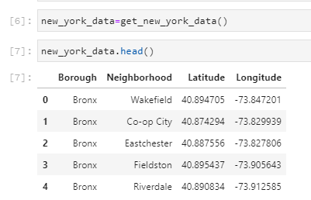

1. Next, using the foursquare API find all venues within each neighbourhood and filter out Italian Restaurants.

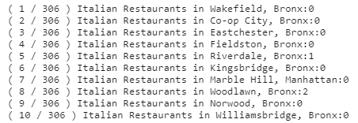

1. Attached each venue to the corresponding Borough and neighbourhood

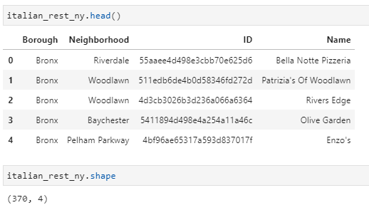

1. Plot the number of Italian Restaurants for each Borough and Neighbourhood in New York.

From the graphs we see that Manhattan is the Borough with the highest number of Italian restaurants while Belmont is the neighbourhood with the most.

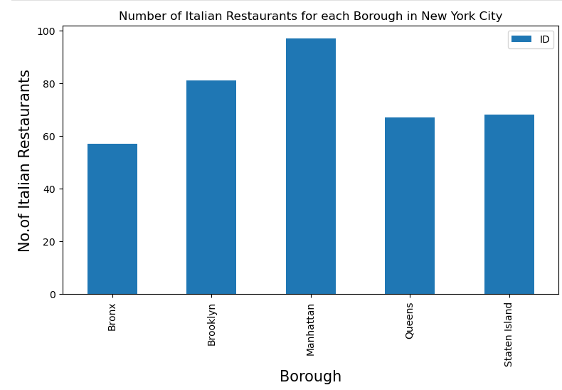

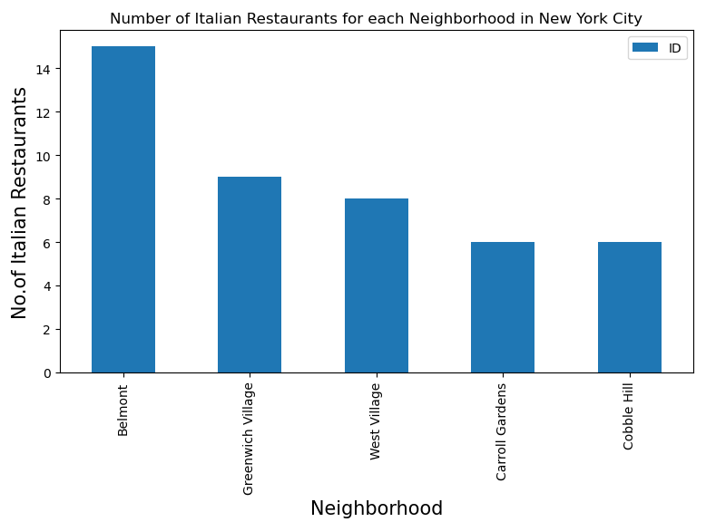

1. Again, using the Foursquare API let’s look at some details about likes, ratings, and tips for each restaurant. (Then attached this data to our main dataset.)

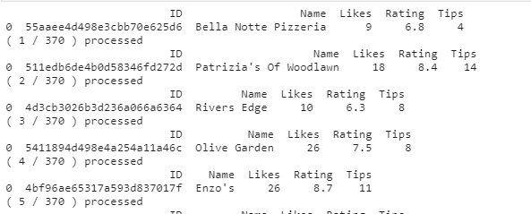

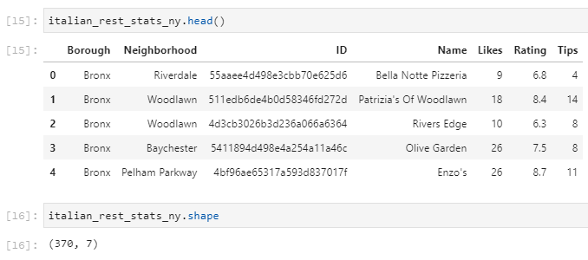

1. Now that we have details about each of the venues, we can use this to find some of the highest liked, rating, and tipped Italian Restaurants and where to find them.

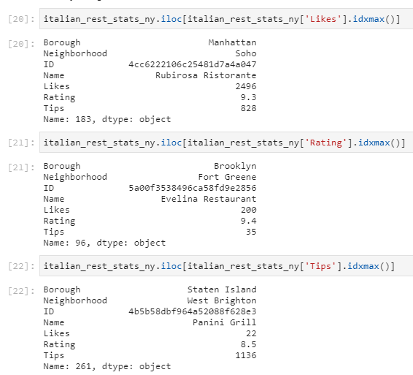

1. Next, let’s sort both the neighbourhoods and boroughs by average rating.

As well as combine the two list.

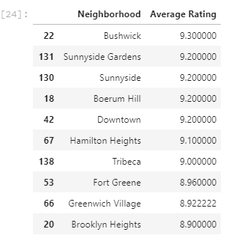

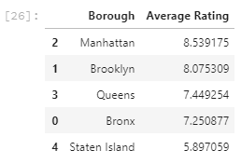

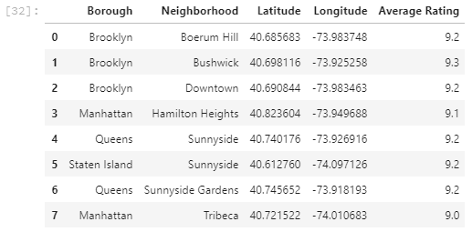

1. Finally, graph each of the 8 restaurants above on a map.

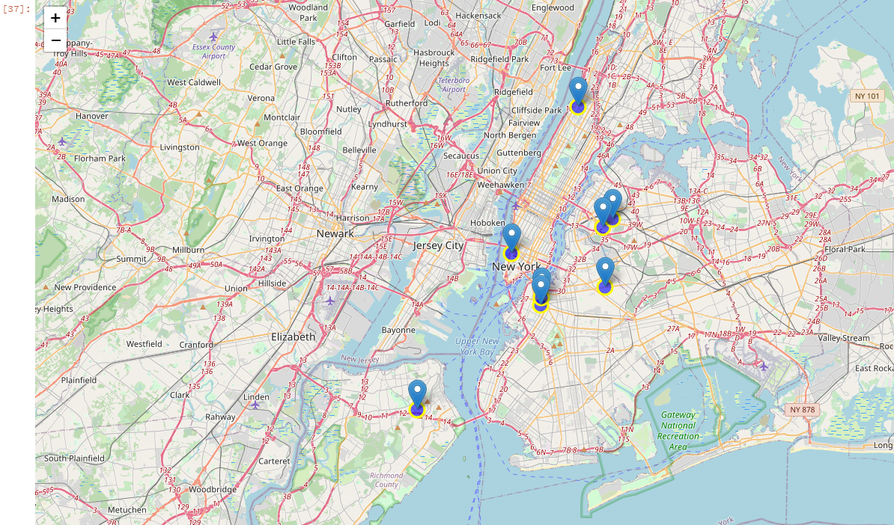

**Result:**

With all the information above lets now answer the questions above.

1. List and visualize all major Italian restaurants within New York City.
   1. See sections 7 and 8 above
2. What are the best neighbourhoods for Italian food based on rating.
   1. The highest rated neighbourhood for Italian restaurants is Bushwick.
3. Which Italian restaurant has the most likes.
   1. Rubirose Ristornate in the Neighbourhood of Soho has the most likes.
4. Which neighbourhoods have the highest number of Italian restaurants.
   1. Belmont has the highest number of Italian Restaurants.

**Conclusion:**

Overall, there are many great options for Italian food while in New York City. This should be used as a guide to some of the best locations and venues for Italian, but nothing beats a in person experience. To improve the usefulness of this report I refresh with current data and incorporate more info about each of the venues.